Case Study of Related Systems

Wikipedia
Mechanics
- Neutral point of view (NPOV)
- Verifiability, not truth

Pros
- Comprehensive
- Open editing and contribution

Cons
- http://www.chronicle.com/article/The-Undue-Weight-of-Truth-on/130704
- Edit wars
- A manifestation of groupthink?

Wikitruth

Stanford’s Encyclopedia of Philosophy
This free online encyclopedia has achieved what Wikipedia can only dream of
http://qz.com/480741/this-free-online-encyclopedia-has-achieved-what-wikipedia-can-only-dream-of/

Where other encyclopedias fall short

Book
Authoritative: √
Comprehensive: X
Up-to-date: X

Crowdsourcing
Authoritative: X
Comprehensive: X
Up-to-date: √

Crowdsourcing + voting
Authoritative: ?
Comprehensive: X
Up-to-date: ?

The Stanford solution

Dynamic reference work
Authoritative: √
Comprehensive: √
Up-to-date: √

Similar Systems
- Quora
- Wikipedia
- StackExchange
- Yahoo! Answers
- Debate.org
- Citizendium
- Snopes.com
- SEP
  - Relies on trust to the expert contributors
- Wikidata - more on tabular data. This alone cannot come up with reasonable arguments.

- Answers.com
- GotQuestions.org
- Conservapedia.com
- Rationalwiki.org
- http://www.dialectic.sg/#scoring

Philosophies of Truth & Reality
- Skepticism
- Empiricism
- Causation

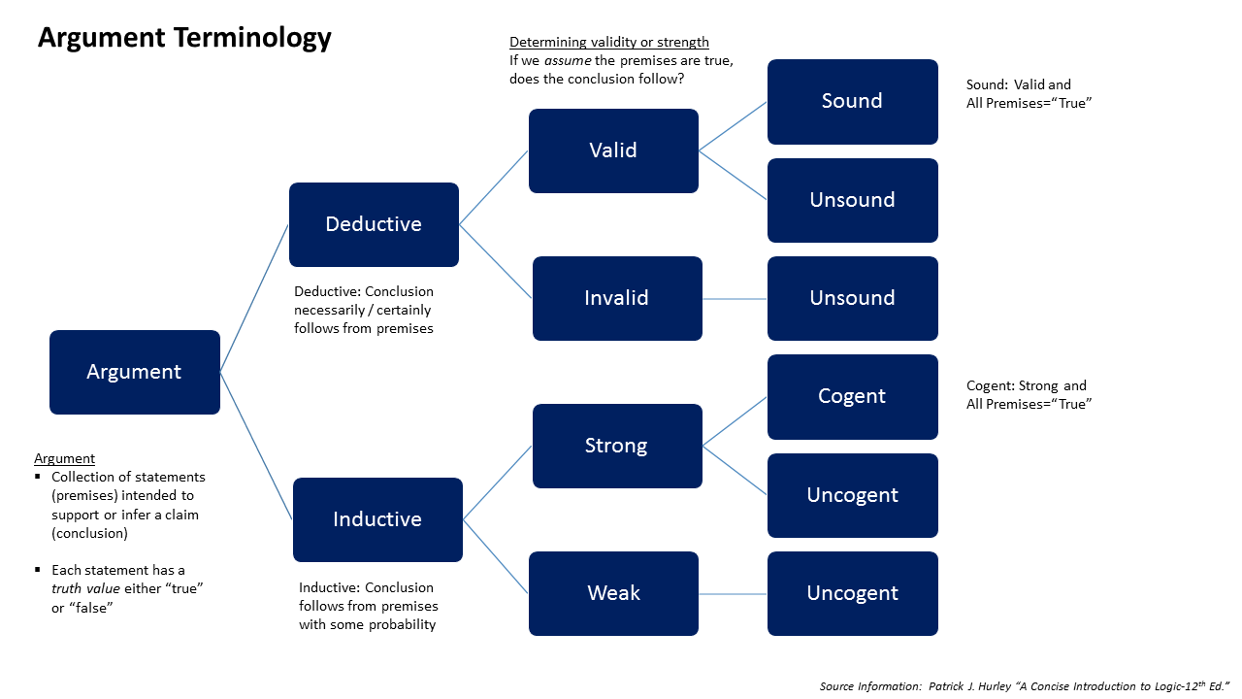

Truth, Philosophy & Psychology
- http://www.philosophybasics.com/
- https://cosmicwhy.wordpress.com/
- http://honestsearchfortruth.blogspot.sg/
- http://changingminds.org/
- http://www.scandalon.co.uk/philosophy/philosophy.htm

- http://www.realsimple.com/work-life/life-strategies/inspiration-motivation/philosophy-101
- http://io9.com/why-agnosticism-probably-doesnt-mean-what-you-think-it-1583312952
- http://forums.philosophyforums.com/threads/counter-argument-for-unmoved-mover-40703-5.html
- http://www.niemanlab.org/2011/10/the-contribution-conundrum-why-did-wikipedia-succeed-while-other-encyclopedias-failed/
- http://cyber.law.harvard.edu/events/luncheon/2011/10/makohill
- http://rationalwiki.org/wiki/Poe%27s_Law
- http://lifehacker.com/5950871/how-to-spot-truth-in-the-sea-of-lies-rumors-and-myths-on-the-internet
- https://github.com/ElDragonRojo/religion
- https://www.quora.com/They-say-do-not-believe-what-you-see-they-also-say-do-not-believe-what-you-hear-So-what-should-we-believe

Discussions going circles
- http://www.scandalon.co.uk/philosophy/cosmological_radio.htm

Satire
- http://www.goodreads.com/review/show/174132767

The Scientific Method
- http://www.oakton.edu/user/4/billtong/eas100/scientificmethod.htm
- https://answers.yahoo.com/question/index?qid=20100816155338AAzP3lN
- http://study.com/academy/lesson/how-does-a-hypothesis-become-a-theory.html

References

https://www.boundless.com/biology/textbooks/boundless-biology-textbook/evolution-and-the-origin-of-species-18/understanding-evolution-124/evidence-of-evolution-498-11724/

http://science.howstuffworks.com/innovation/scientific-experiments/10-scientific-laws-theories.htm

http://arstechnica.com/tech-policy/2011/10/five-year-old-wikipedia-fork-is-dead-in-the-water/?comments=1

"I have a PhD from a top school in a complex, highly theoretical discipline. Approving of the idea to make science more accessible to the masses, I trundled off to Wikipedia and set up information relevant to my field. It was edited out and defaced by typical internet know-it-alls who replaced discussions of cutting-edge research with truisms they found on Ask.com. There were thousands of them and one of me. They had spent all of 15 minutes research the topic on Google, I had spent 10 years and a dissertation on it.
I haven't been back. And actually, none of my colleagues have either.
Knowledge isn't democratic - until the internet figures that out, it's only helping to drag us further into the dark ages."

(AK-47) This guy gets it, people aren't interested in concise just-the-facts traditional encyclopaedia-type entries like that Citizendium example, they want big agglomerations of less-reliable, less-objective information that are more like magazine pieces, like the Wikipedia article.

Please read closely as I list again, I’m judging it on three things:
1) dearth of information, the top of the Wiki page has the summary, the subsections (if you are on a mobile platform they probably aren’t even open by default) are the [optional] extra detail…yes, sometimes I just stop at the header
2) not pointing me towards its underlying data sources so I can better judge the veracity of its [meager] assertions
3) not pointing me towards its underlying data sources so I can go learn even more
P.S. Point #2 especially makes me very uneasy about its reliability, because I take the potential abuse for Appeal to Authority seriously. Lack of transparency is the selling point? Little to no option to drill down for more detailed info is the selling point? WTF?

http://www.conservapedia.com/
Wow, this website is a hoot. I got a kick out of the "Causes of Homosexuality" page.

Examples:
- http://www.abovetopsecret.com/forum/thread163678/pg1
- http://humansarefree.com/2013/12/9-scienctific-facts-prove-theory-of.html

The problem is the public. They want to believe and not think. The apathy is not with the volunteers but with the users. Not just the users of Wikipedia but the users of the internet and the users of mass media. My experience is that the average American brain is dead. They use to say that we use 10% of our brain power. Bahh... Average Joe uses zero.
It starts in the education system where they teach beliefs instead of examination and evaluation techniques. They teach people how to believe and not how to think. It starts even before grade school because parents don't think but simply believe. My favorite example is Bill Maher asking various politicians if they believe in evolution. Evolution is a theory. Its not suppose to be a belief but yet, most people, even scientists, believe in evolution.
The difference is faith. A belief culminates in faith and a true scientist should not have faith in a theory. They should question it, test it, examine it, probe its implications -- but never put faith into it. Yet they do because that is how the system trains them. People have faith in scientists, doctors, politicians, and clergy. Yet all of them have proven to be frail, corrupt at times, and evil at other times.
Instead of researching and reasoning concepts, viewpoints, and data, people want a simple answer that they can just accept. I recall my dad and my older sister. She just wanted the answers to her homework but dad would try to get her to work the problem. Most dads don't even try because they don't know the difference because their dad didn't try because they didn't know the difference ...
And there are turtles all the way down to the bottom…

As a side-note: "A fool's brain digests philosophy into folly, science into superstition, and art into pedantry. Hence University education".
- George Bernard Shaw
Yeah? Really?
Science Safely!
- Dr. Anna

Sources
http://www.lukemastin.com/meet.html
- Wikipedia (probably the main single source)
- Stanford Encyclopedia of Philosophy
- The Internet Encyclopedia of Philosophy
- The Catholic Encyclopedia
- Philosophy Pages
- Said What? Philosophy Quotes
- "Microsoft Encarta Encyclopedia" 2003
- "Philosophy Made Simple" (Heinemann London Books, 1981)
- "Philosophy for Beginners" by Richard Osborne (Writers and Readers Publishing, 1992)
- "The Great Philosophers: An Introduction to Western Philosophy" with Bryan Magee (BBC TV series, 1987)

Notable links
- https://en.wikipedia.org/wiki/Wikipedia:Requests_for_permissions (wikipedia list of permissions)
- https://en.wikipedia.org/wiki/Wikipedia:Why_create_an_account%3F (benefits of having an account)
- https://www.engadget.com/2017/04/21/we-need-more-projects-like-usafacts/
- http://www.zdnet.com/article/heres-how-steve-ballmer-is-building-a-huge-u-s-government-data-repository/
- http://kellymom.com/ages/newborn/nb-challenges/back-to-breast/
- http://www.auburn.edu/academic/education/reading_genie/Fact-opinion.html (fact vs opinion)
- https://www.facebook.com/TED/posts/10158768073950652 (global economic control)
- https://www.skepticalscience.com (argument, comments format)
- https://www.facebook.com/TED/posts/10157768262500652 (How false news can spread)

Related Technical Materials

Top Reference Sites
- Quora
- Stack Exchange
- GitHub
- Wikipedia
- reddit
- 9GAG (comments section on app)
- Imgur
- Medium
- Facebook

Timeline
http://xhpfm.mobile.zhongguowangshi.com/scene/?docid=1017737
https://techcrunch.com/2015/06/06/you-cant-handle-the-truth/
http://www.huffingtonpost.com/omar-alnatour/muslims-are-not-terrorist_b_8718000.html

http://www.bbc.com/news/science-environment-26258662
http://bigthink.com/think-tank/is-the-brain-hardwired-for-religion
http://thoughtcatalog.com/taylor-george/2014/08/are-there-really-bad-people-in-this-world/
https://africacheck.org/2014/02/28/the-battle-between-intuition-and-logic/

http://portland.indymedia.org/en/2006/05/338820.shtml?discuss

https://css-tricks.com/examples/ReadMoreFade/
https://github.com/elendirx/web2web

Data Zooming / Visualization
https://www.jasondavies.com/wordtree/
https://github.com/VisualDataWeb ****
https://github.com/d3/d3/wiki/Gallery
http://charts.animateddata.co.uk/datavistree/ (http://mbostock.github.io/d3/talk/20111018/tree.html **)
https://mohansun-canvas.herokuapp.com/content/training/ **
http://bl.ocks.org/mbostock/2706022 *
http://www.redotheweb.com/CodeFlower/
http://bl.ocks.org/robschmuecker/7880033 ***
https://bl.ocks.org/mbostock/4063570 *
https://bl.ocks.org/mbostock/4339184 *
http://bl.ocks.org/mbostock/1153292 *
https://bl.ocks.org/mbostock/e9ba78a2c1070980d1b530800ce7fa2b
http://bl.ocks.org/emeeks/4733217 **
https://github.com/emeeks
https://www.text2mindmap.com/ ** MindMap spider web, no source?
http://bl.ocks.org/jdarling/2d4e84460d5f5df9c0ff *
https://gist.github.com/emeeks/4733217
https://www.codeproject.com/Articles/16192/Graphic-JavaScript-Tree-with-Layout
https://gist.github.com/emeeks/4733217
http://ideas.ted.com/gallery-how-networks-help-us-understand-the-world/
http://www.simpleapps.eu/simplemind/

https://www.facebook.com/5min.crafts/videos/764886210320633/
https://upload.wikimedia.org/wikipedia/commons/8/85/Quake_-_family_tree_2.svg
https://meta.wikimedia.org/wiki/2010_Wikimedia_Study_of_Controversial_Content:_Part_Two#It_is_recommended:
http://video.cnbc.com/gallery/?video=3000578051

https://en.wikipedia.org/wiki/List_of_fallacies
https://www.youtube.com/watch?v=0GS2rxROcPo

http://www.haaretz.com/middle-east-news/1.570727

Expand/Collapse content area:
https://jira.atlassian.com/browse/SRCTREEWIN-2093?attachmentOrder=asc

Details
http://www.bbc.com/news/world-asia-15521300 (Entry Overview)
https://www.ted.com/talks/ze_frank_s_nerdcore_comedy (Entry Overview, check both Desktop and Mobile versions)
https://www.glassdoor.com/Reviews/The-Borgen-Project-Reviews-E465080.htm (Entry Overview)
http://www.bbc.com/news/world-asia-15521300 (Entry Overview, elements)
https://github.com/npm/npm/releases/tag/v5.0.0 (overall entry layout)
https://medium.com/@bherbst/managing-the-fragment-back-stack-373e87e4ff62
https://www.gamespot.com/articles/blizzard-talks-starcraft-remastered-and-why-it-des/1100-6451524/

UX / Sidebar
https://www.asus.com/zentalk/thread-6557-1-1.html (very nice list UX)
http://www.diabetes.co.uk/forum/threads/goodbye.127888/ (check the post reactions)
https://community.alohabrowser.com/ (very nice as well)
https://docs.microsoft.com/en-us/sql/linux/sql-server-linux-setup-tools#macos (Sidebar)
https://github.com/golang/go/wiki (Sidebar)
https://github.com/twbs/bootstrap/issues/4215 (conversation locking)
https://community.atlassian.com/t5/Sourcetree-questions/Why-is-sourceTree-showing-changes-when-there-are-none/qaq-p/186916 (coversation)

https://www.verywell.com/bmi-what-is-bmi-or-body-mass-index-3120088 (nice UX and typo)
http://www.independent.co.uk/voices/hillary-clinton-wikileaks-email-isis-saudi-arabia-qatar-us-allies-funding-barack-obama-knew-all-a7362071.html (nice typo)
https://www.digitalocean.com/community/tutorials/how-to-upgrade-to-ubuntu-16-04-lts
https://www.digitalocean.com/community/users/mati
https://www.ninds.nih.gov/Disorders/Patient-Caregiver-Education/Fact-Sheets/Guillain-Barr%C3%A9-Syndrome-Fact-Sheet (very nice typography)
https://www.change.org/
https://github.com/ftlabs/fastclick (disable 300ms click delay)
http://thegardenisland.com/news/opinion/guest/zuckerberg-we-are-dropping-our-quiet-title-actions/article_e80fc17c-e4b1-11e6-bc5c-9308d8f880f4.html (using tabs but in the same page)
https://community.letsencrypt.org/latest
https://community.letsencrypt.org/t/help-cant-renew-ubuntu-14-upgraded-to-16/20501/2
https://www.slant.co/topics/6631/~gtx-1060-cards
https://www.slant.co/topics/6631/viewpoints/2/~gtx-1060-cards~msi-geforce-gtx-1060-6gb-gaming-x
https://software.intel.com/en-us/articles/what-is-intel-rapid-start-technology
http://www.techradar.com/reviews/phones/mobile-phones/hp-elite-x3-1315327/review
http://www.webmd.com/a-to-z-guides/understanding-tinnitus-treatment
https://beta.groups.yahoo.com/neo/groups/PSITE-BOARD_regl_prexy_2009_11/info
https://www.quora.com/topic/Facebook-company/manage (Entry Settings)

http://www.cssreset.com/demos/layouts/how-to-keep-footer-at-bottom-of-page-with-css/ (sticky footer)

Markdown Editors
- http://iphands.github.io/Meltdown/

Tools
- http://www.favicon-generator.org/
- https://github.com/punkave/sanitize-html

Projects
- Discourse - https://github.com/discourse/discourse
- Atlassian Answers - https://answers.atlassian.com/
- Github - https://guides.github.com/

User Management
- https://github.com/jedireza/drywall
- https://github.com/jedireza/aqua/
- https://github.com/jedireza/frame

Forum
- https://nodebb.org/

Wiki/CMS
- https://github.com/gilbitron/Raneto (static, md-based, nice layout)
- https://github.com/claudioc/jingo (uses git as db)

UI & UX
- Slack Account page
- http://forum.paperpile.com/t/resolved-performance-in-google-docs/121 (Threads)

Editor / Markdown
- http://upndown.netgusto.com/ (Nice side-by-side editor)
- http://jbt.github.io/markdown-editor/ (basic with highlight)
- https://github.com/chjj/marked
- https://github.com/evilstreak/markdown-js

- https://github.com/benweet/stackedit (Used by Stack Overflow)
- http://dillinger.io/
- http://markable.in/

Push Menu
- http://takien.github.io/jPushMenu/
- http://www.stampede-design.com/blog/2014/08/responsive-bootstrap-push-menu-using-jpushmenu/#.Vjstea4rInc
- http://www.jasny.net/bootstrap/javascript/#offcanvas, http://www.jasny.net/bootstrap/examples/navmenu/
- https://elements.polymer-project.org/elements/paper-menu

Timeline
- https://github.com/netgusto/upndown/issues/1

Questions & Answers
- http://meta.stackexchange.com/questions/2267/stack-exchange-clones
- http://stackoverflow.com/posts/26614972/edit
- http://stackoverflow.com/help/privileges/edit (Guides)
- http://meta.stackexchange.com/questions/19756/how-do-comments-work

Website Materials
- https://pixabay.com/en/book-books-circle-curly-education-2869/

